Clases semana 28/08 al 01/09

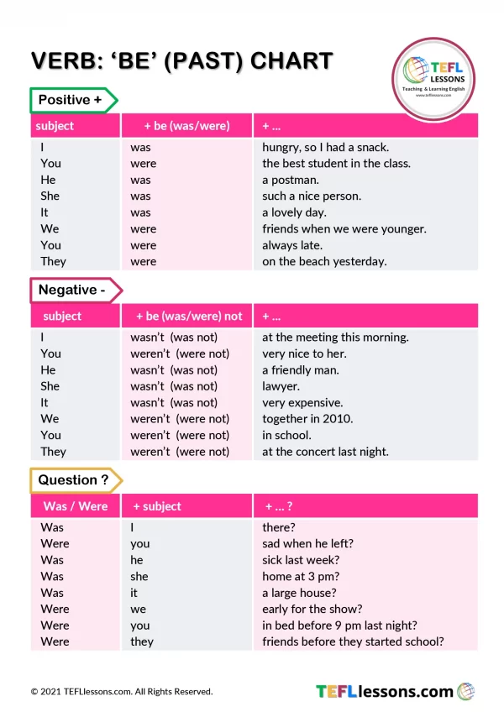

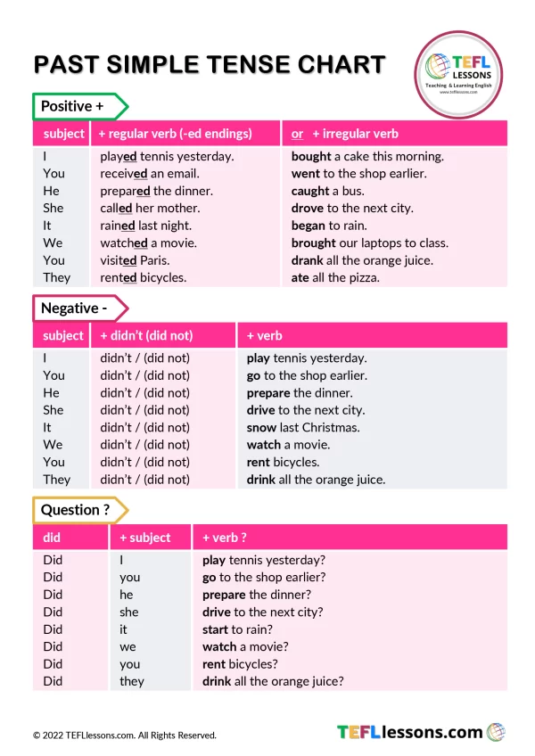

Explanation in Spanish:

<https://www.blueblocnotes.com/grammar/past-tenses/to-be-past-tense>

<https://www.blueblocnotes.com/grammar/past-tenses/past-simple>

# 

# Past simple

With most verbs, the past tense is formed by adding *–ed*:

| *call****ed*** | *lik****ed*** | *want****ed*** | *work****ed*** |
| --- | --- | --- | --- |

But there are a lot of irregular past tense forms in English. For example:

am/is/are - was /were

break - broke

go - went

have/has - had

We use the past tense to talk about:

* something that happened **once in the past**:

*I* ***met*** *my wife in 1983.  
We* ***went*** *to Spain for our holidays.  
They* ***got*** *home very late last night.*

* something that happened **several times in the past**:

*When I was a boy, I* ***walked*** *a mile to school every day.  
We* ***swam*** *a lot while we were on holiday.  
They always* ***enjoyed*** *visiting their friends.*

* something that was **true for some time in the past**:

*I* ***lived*** *abroad for ten years.  
He* ***enjoyed*** *being a student.  
She* ***played*** *a lot of tennis when she was younger.*

* we often use **expressions with *ago*** with the past simple:

*I* ***met*** *my wife* ***a long time ago****.*

## Past simple questions and negatives

We use ***did*** to make [questions](https://learnenglish.britishcouncil.org/node/1363) with the past simple:

***Did*** *she* ***play*** *tennis when she was younger?****Did*** *you* ***live*** *abroad?  
When* ***did*** *you* ***meet*** *your wife?  
Where* ***did*** *you* ***go*** *for your holidays?*

But questions with *who* often don't use *did*:

***Who discovered*** *penicillin?****Who wrote*** *Don Quixote?*

We use **didn't** (**did not**) to make [**negatives**](https://learnenglish.britishcouncil.org/node/1363)with the past simple:

*They* ***didn't go*** *to Spain this year.  
We* ***didn't get*** *home until very late last night.  
I* ***didn't see*** *you yesterday.*

**Let´s practice:**

<https://learnenglish.britishcouncil.org/grammar/english-grammar-reference/past-simple>

**Oral activity**

In pairs, ask and answer the following question: What did you do yesterday in class?

Clases semana 04/09 al 08/09

Modal Verbs

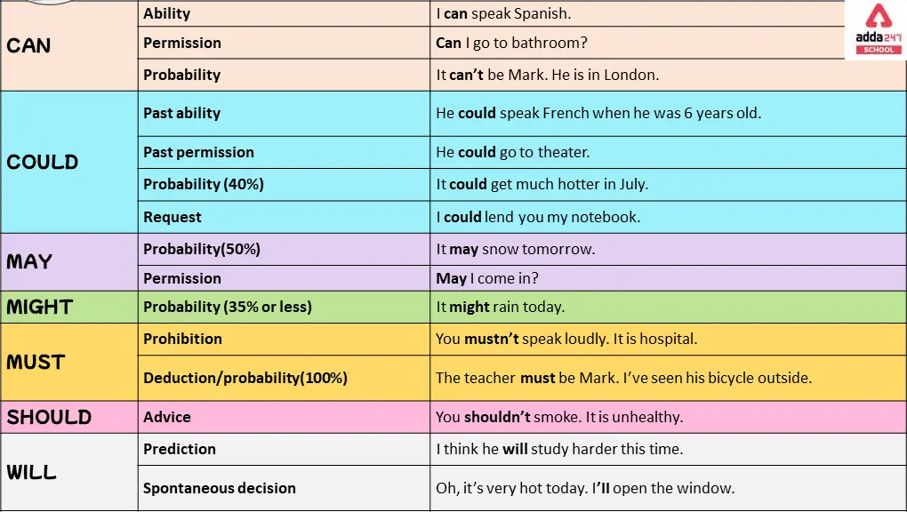

Explanation in Spanish:

<https://www.blueblocnotes.com/grammar/modal-verbs/general>

Listening activity and exercises:

<https://learnenglishteens.britishcouncil.org/skills/listening/a1-listening/online-safety-conversation>

### 

### From the audio transcript, identifies the modal verbs and their uses

### [Transcript](https://learnenglishteens.britishcouncil.org/skills/listening/a1-listening/online-safety-conversation#)

Charlie: Mum! That's my computer!

Mum: I know, I know. Don't worry, I'm changing your privacy settings.

Charlie: Privacy settings?

Mum: Yes. There are privacy settings on your social networking sites. Your account is totally public at the moment, and you're logged in!

Charlie: Oh. What are the privacy settings for?

Mum: To make you safe online. You want to be safe, don't you? And for the right people to see your information, not EVERYONE. (Modal verb: want to)

Charlie: Everyone?

Mum: Yes. If you don't change your privacy settings, when you upload a photo, anyone can see it. It's important to change them so only your friends can see them. You don't want everyone to see everything, do you? Modal verb: can

Charlie: No! But I can delete things, can't I? Modal verb: can, can´t

Mum: Well, you can, but it's very difficult. Some things stay there forever. Modal verb: can

Charlie: That's really scary, Mum.

Mum: Don't worry, but you must learn how to stay safe. You mustn't tell anyone your password! Modal verb: must, mustn't

Charlie: I won't! Modal verb: won't

Mum: Crazy Charlie one two one, isn't it?

Charlie: Mum! Yes, it is. How …

Mum: It's on your notebook. Right there. On your desk. It isn't a very secret place, is it?

Charlie: No, it isn't.

In the given text, the modal verbs used and their uses are as follows:

* want to: Expressing desire or preference
* can: Expressing ability or possibility
* must: Expressing necessity or obligation
* mustn't: Expressing prohibition
* won't: Expressing refusal or unwillingness

Oral activity:

Answer the following question: What can you do in your technical course?

For example:

As an English teacher, a **can** teach students from all over the world.

Extra practice:

<https://wordwall.net/es/community?localeId=11274&query=modal%20verbs>